MedianIncome

Table as per design

The Data type are the same

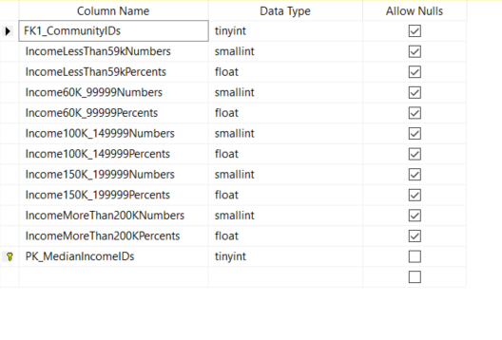

Rows retrieved 198 rows

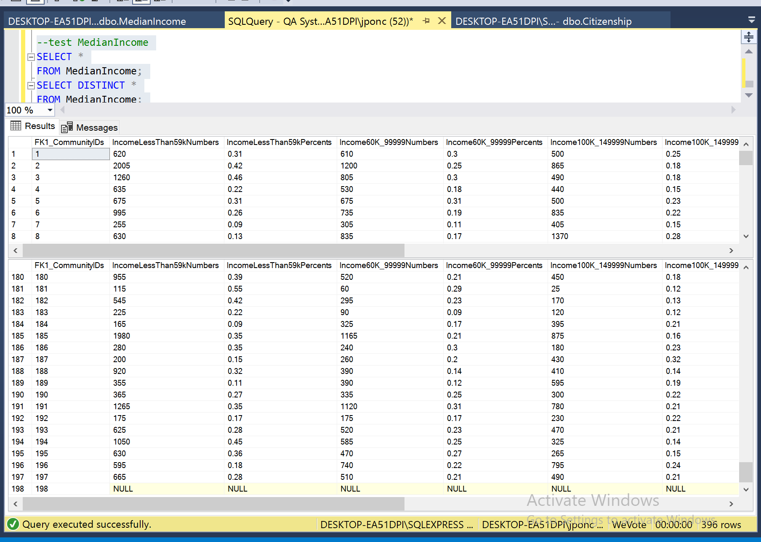

Data Manipulation

Join

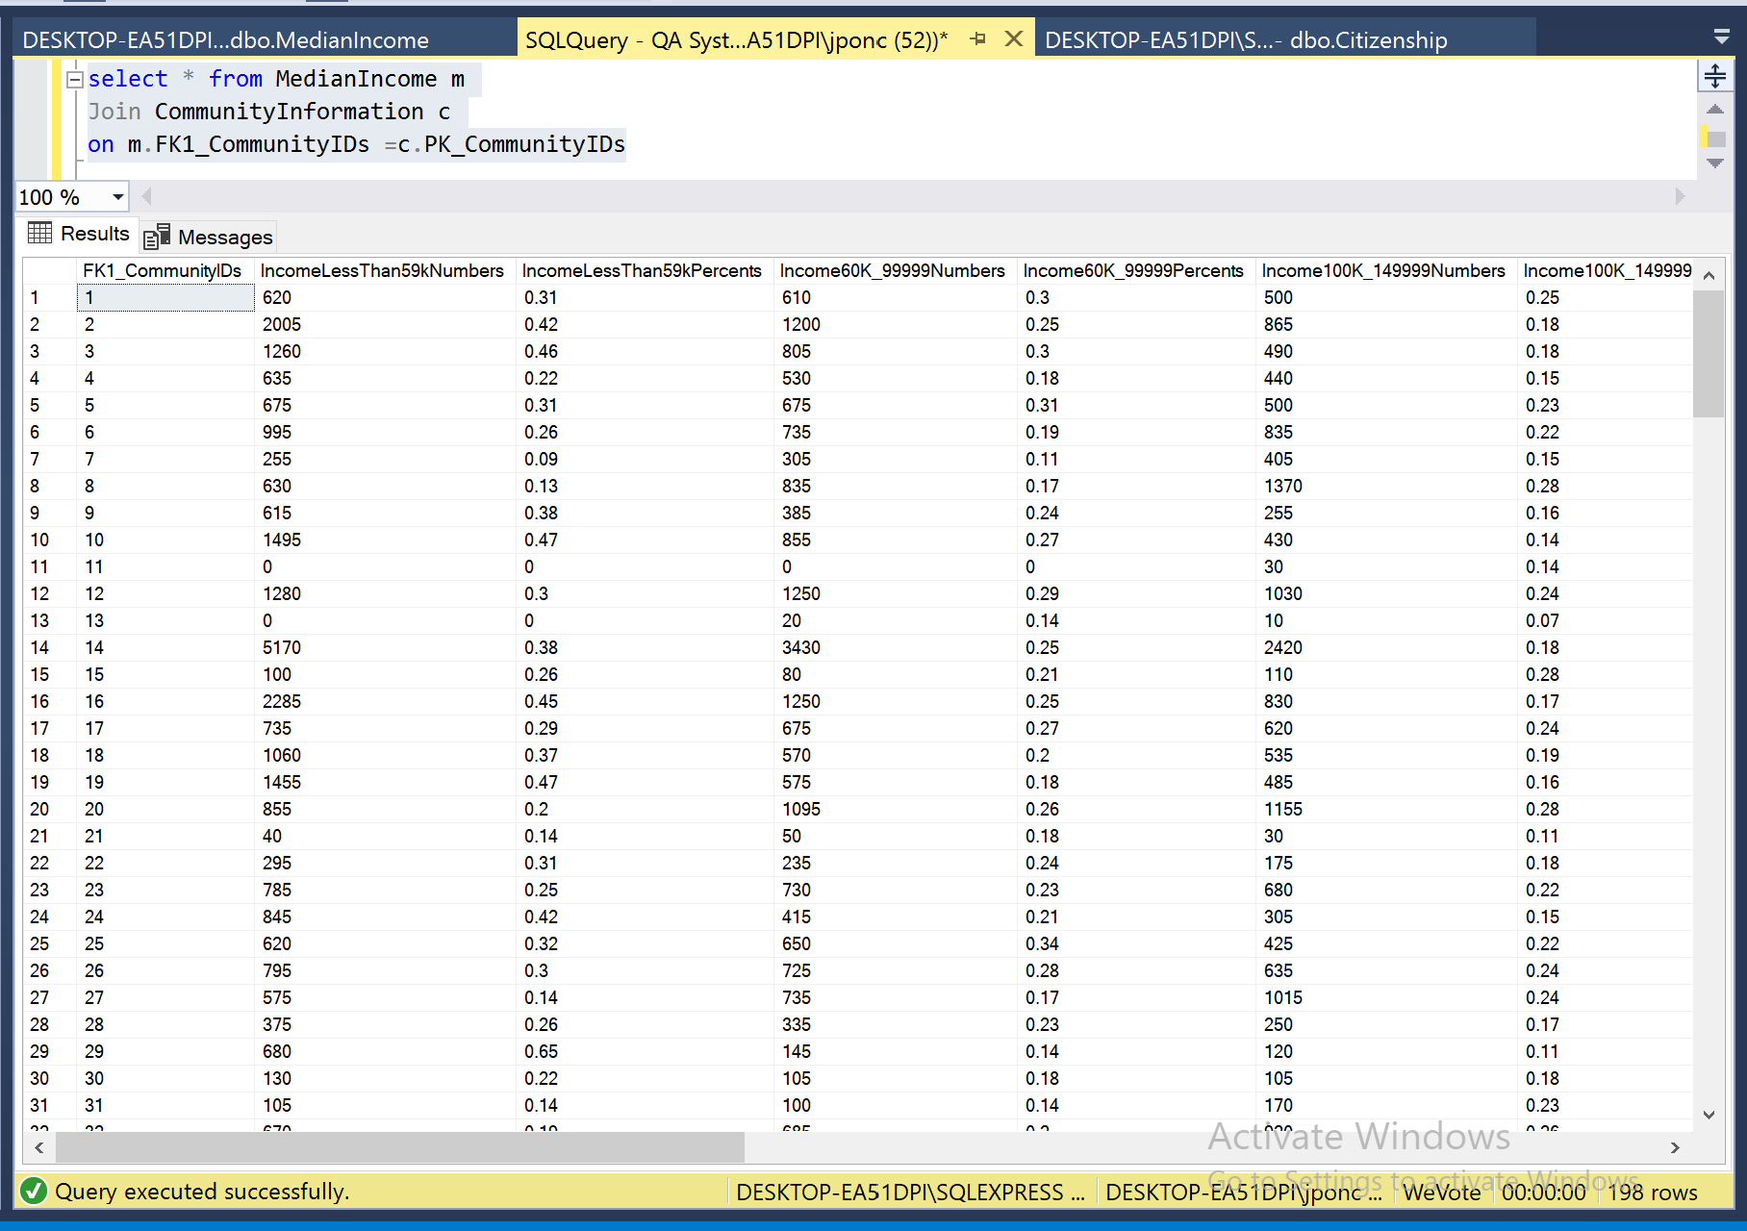

Primary Key - Explicit Insert for Identity Column

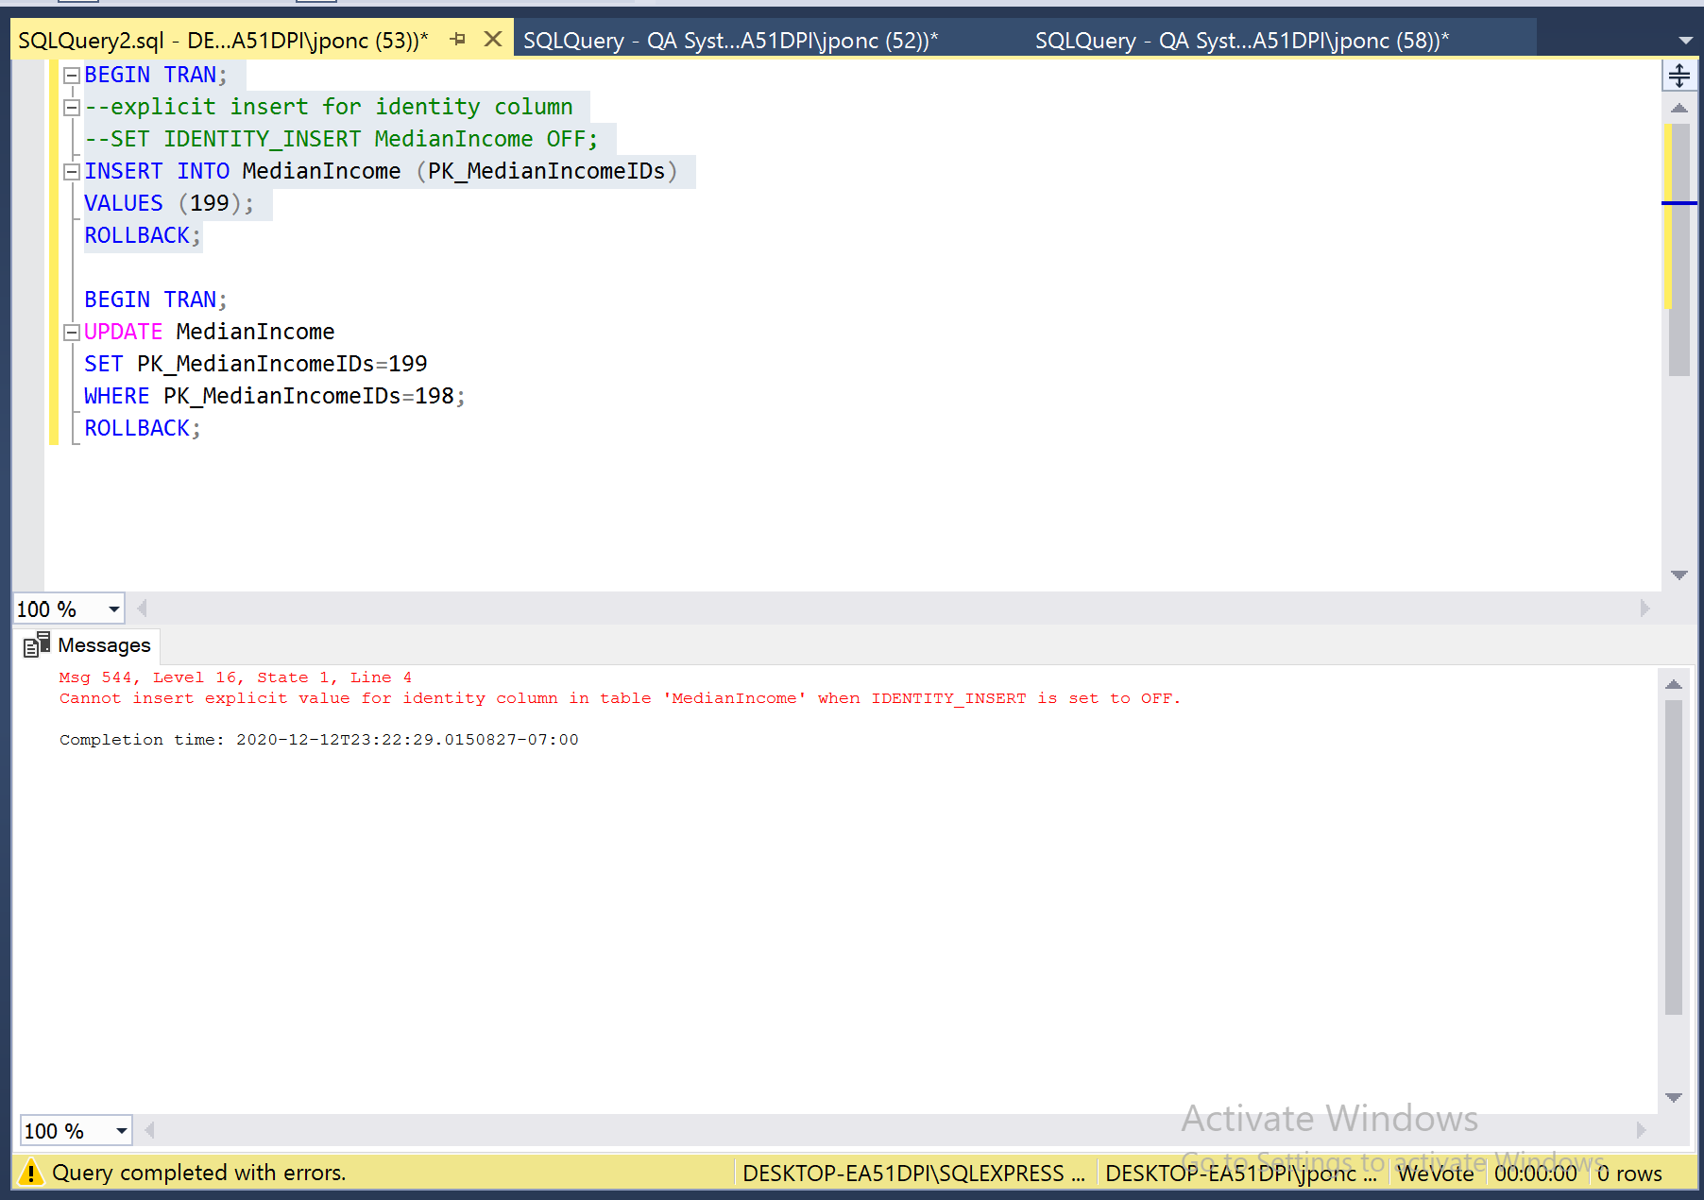

Primary Key – Update

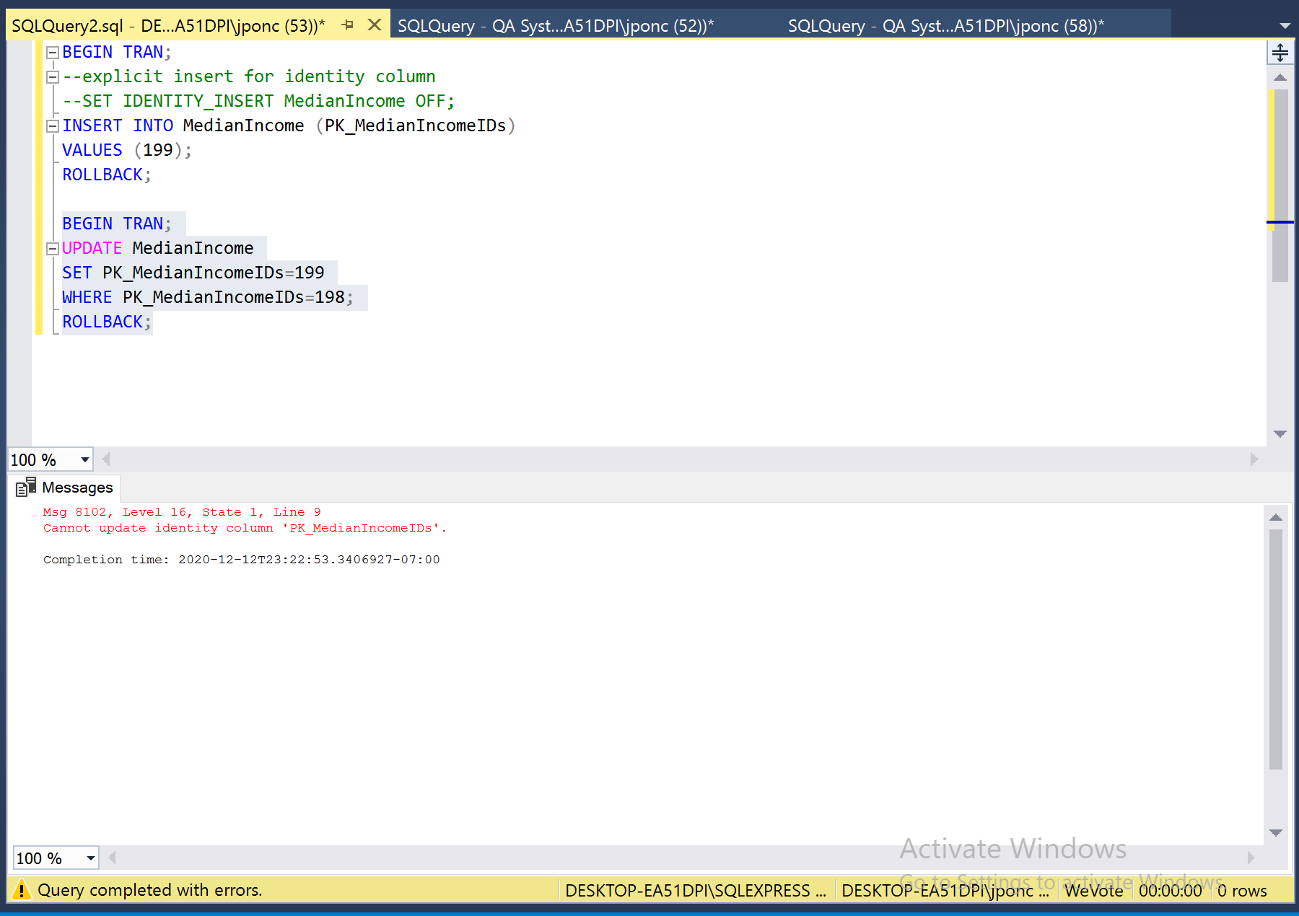

Primary Key not related to other and with Foreign Key

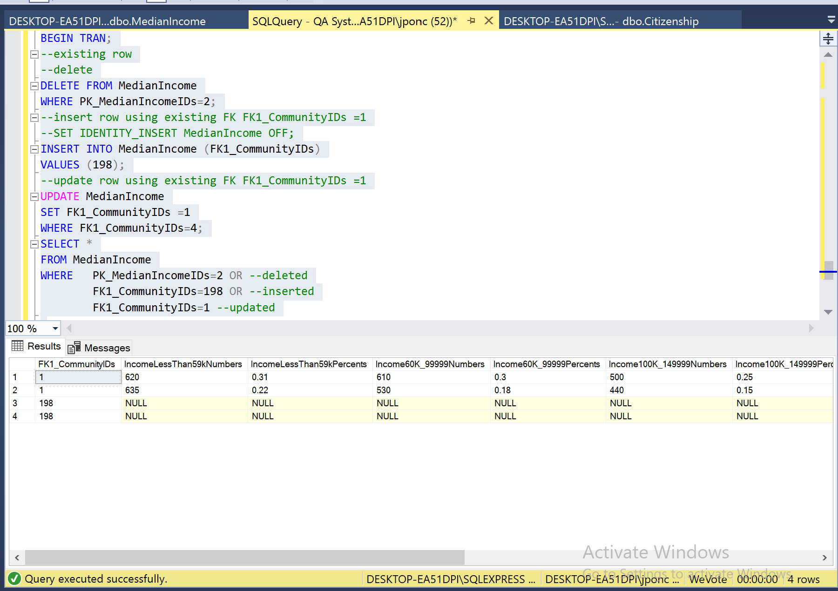

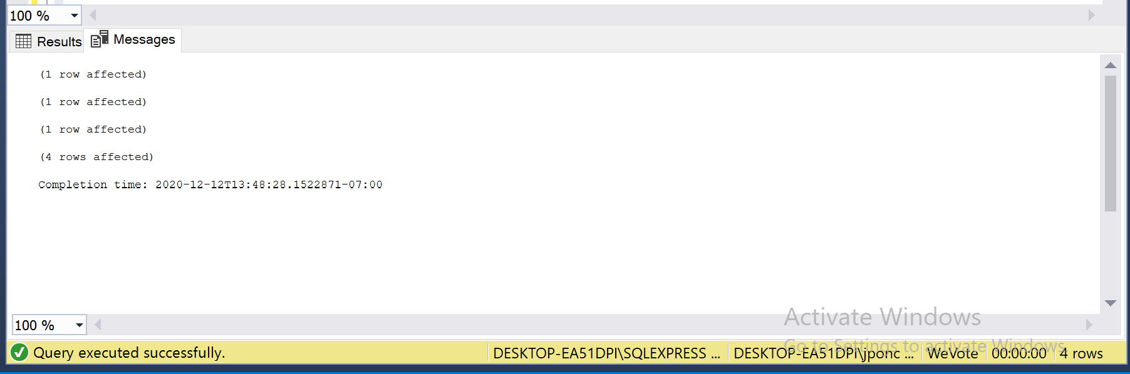

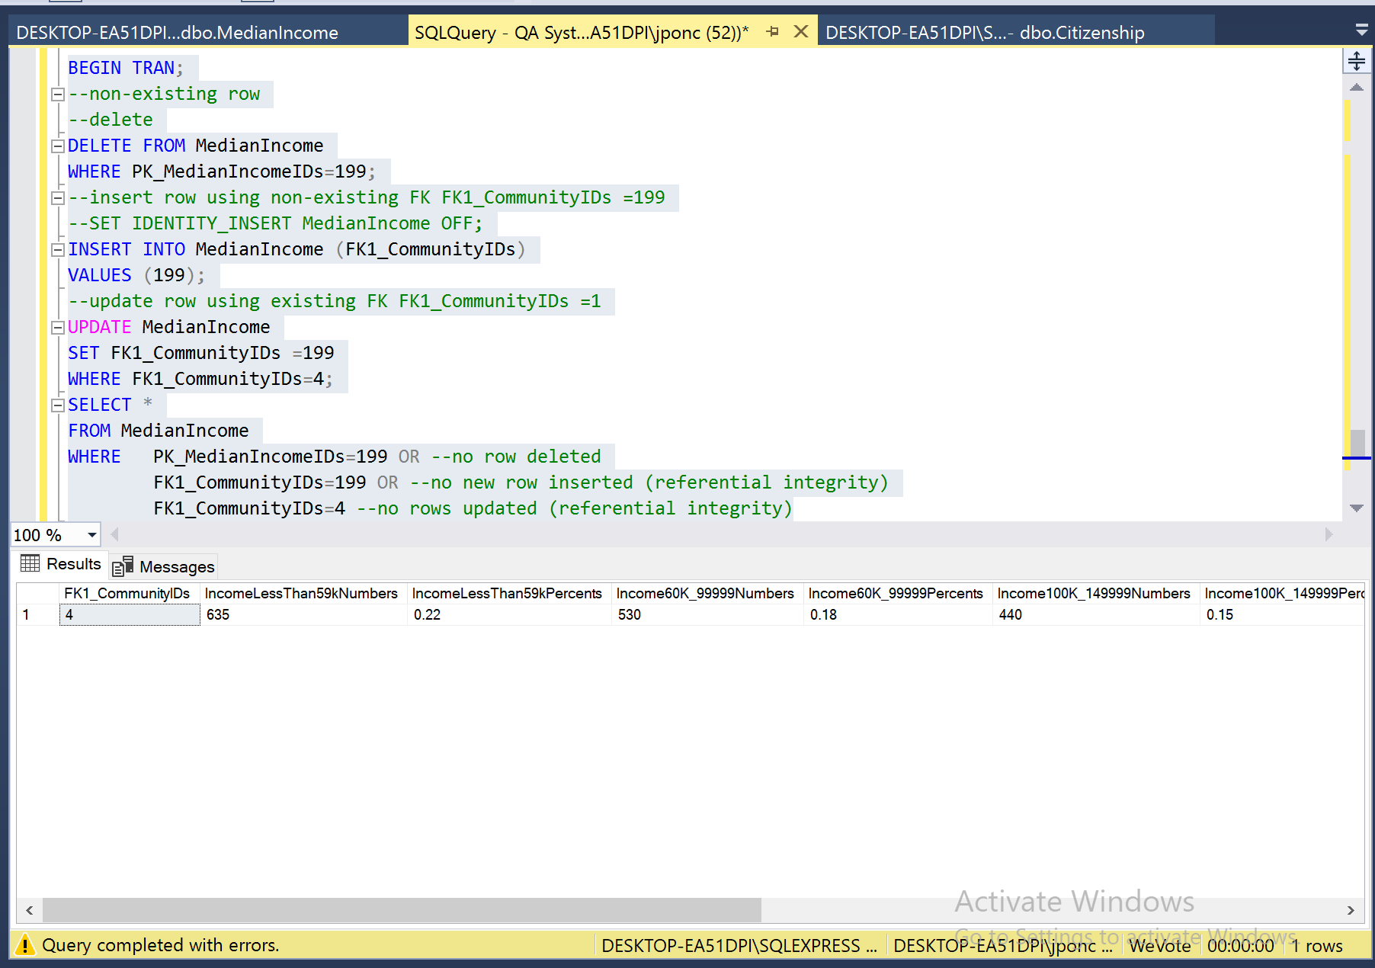

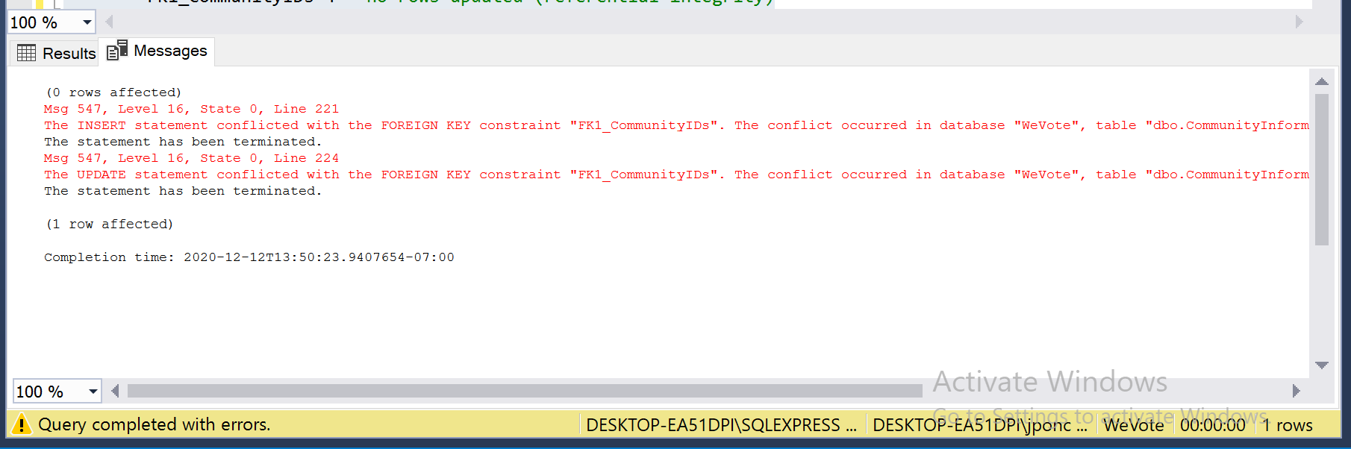

## For table MedianIncome:

The fig below show the column that allow Nulls



Executing

Begin Transaction

insert into MedianIncome(IncomeMoreThan200KNumbers)

Values('999')

select * from MedianIncome

where IncomeMoreThan200KNumbers =999

ROLLBACK

No error generated because alone Pk_MedianIncomeIDs as the not null constraints



Executing

Begin Transaction

insert into MedianIncome(PK_MedianIncomeIDs)

Values(Null)

Error DEFAULT or NULL are not allowed as explicit identity values. was generated because column PK_MedianIncomeIDs as the not null constraints

# **MedianIncome** **Table**

Constraint on MedianIncome table

CONSTRAINT [Income100K_149999Numbers] CHECK (([Income100K_149999Numbers]>=(0)))

**Execution**

Begin Transaction

insert into MedianIncome(FK1_CommunityIDs,Income100K_149999Numbers)

Values('1','-130')

Error The INSERT statement conflicted with the CHECK constraint "Income100K_149999Numbers". The conflict occurred in database "WeVote", table "dbo.MedianIncome", column 'Income100K_149999Numbers' is generated validating the constraint given

The other check constraint follows the same format

